TRAVELER’S EYE

**Introduction:**

Being international students we all understand the intricacies involved in travel. The stress of keeping track of all the information about the destination and the travel, especially when it comes to travelling alone, takes away from the fun one can have while travelling. Traveler’s eye is aimed to make a traveler’s life easy by providing relevant useful information whenever the user needs it, at a simple button click or the touch of a finger.

**Services Designed in Fourth Increment:**

Sending an email to the user using SMTP

Entertaining user by providing a game(Snake Food)

Text to Voice Functionality

Deployment of redesigned DB and sign up and login functionality

Photo and Gallery

Traveler’s Eye Website

**CLASS DIAGRAM :**

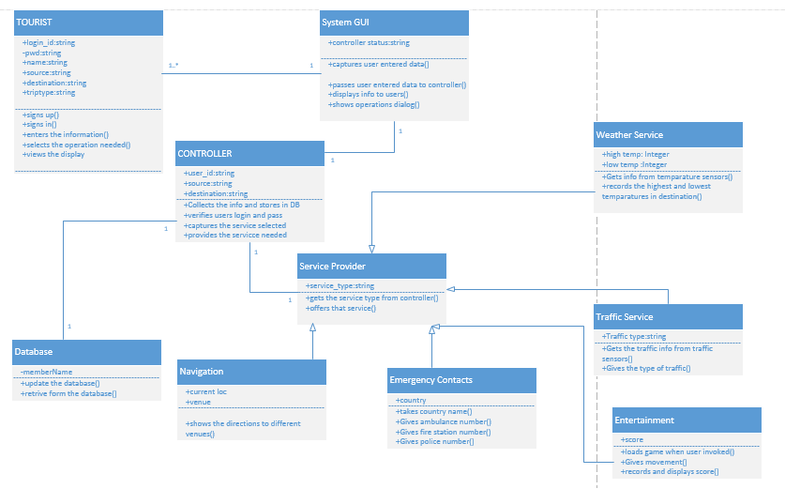

The class diagram describes the static structure of the application. The class diagram consists of classes, attributes and operations.

**Classes:**

Tourist: This class refers to the user of the application. The user should first sign up with application and them login into it and give his details. And then can use the services of the application.

SystemGUI: This is the interface between the user and the application. It captures the users data and passes it on to the controller .And displays the useful information to user as requested by the controller.

Controller: This is the heart of the whole application. It analyses everything. It updates and verifies database. Contacts the service provider and the brings the service needed into play.

Service Provider: This is used to provide services to the application. Each service is asub class to this super class.

1) Weather Service: This gives the weather conditions at the given destination.This gives the highest and lowest temperatures at the given position.

2)Traffic service: This gives the traffic updates at the place required by the user.

3)Entertainment: Provides a game to entertain the user as travelling is boring activity.

4)Navigation: This shows the navigation from to user’s current position to the place he wants to move.

5)Emergency Contacts: The user can get the emergency contacts like ambulance fire and police man.

Sequence Diagram For Email System :

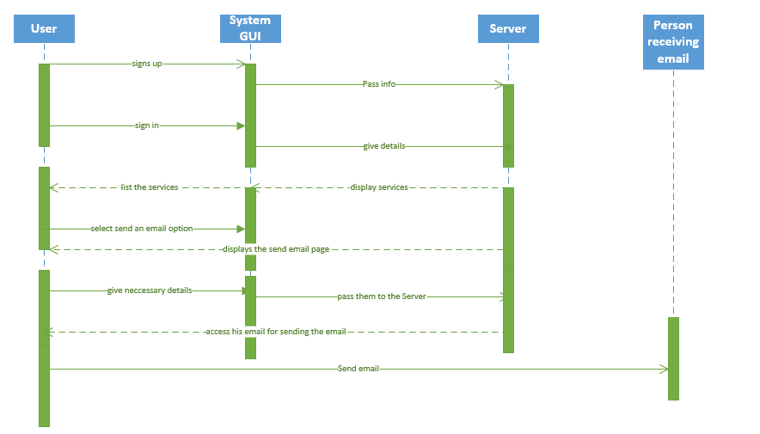

**Entertainment (Snake food game) :**

Travelling is always a boring activity. Especially when we travel alone. So our application also providea the user with some entertainment. Using this application he can play games like snake food game.

When the user is bored he just need to click a button and he will get the game and he can play the game.

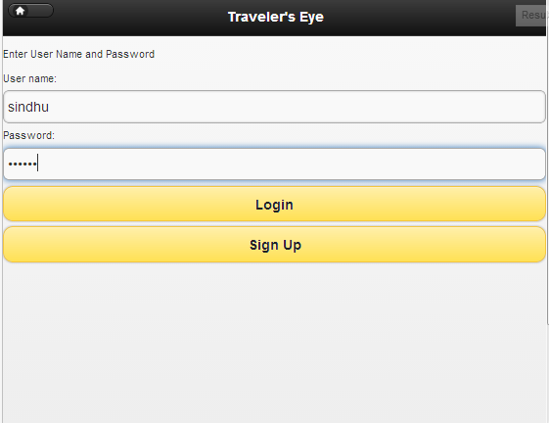

As soon as you log in you can find the game button.

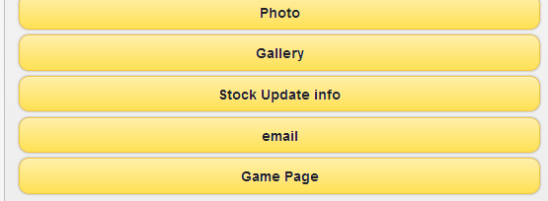

By click on the button you will be directed to the game page. Where you can play a game.

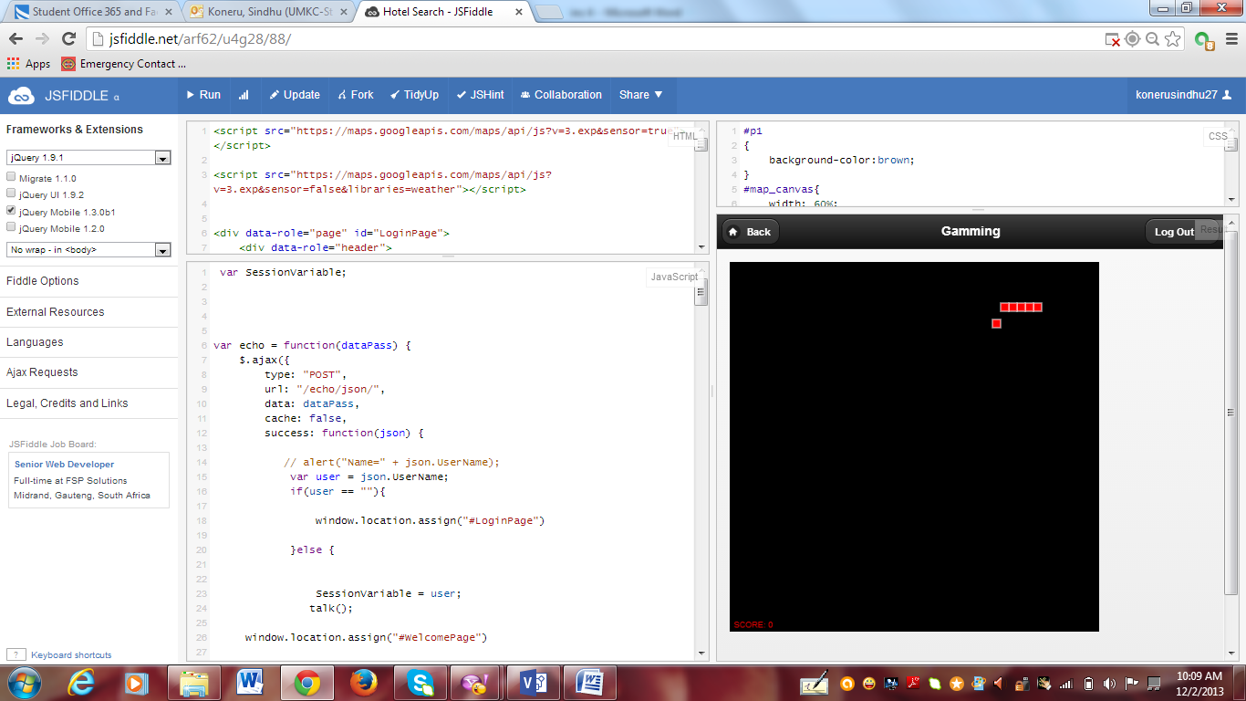

The snake over here should take the food.

To move the snake we use arrow keys. If it hits the wall it gets disappeared. And game starts again.

Score will be displayed at the bottom.

It is a full entertaining game.

**Sending an Email:**

This feature is adverted into the project with an intension of allowing user to leave an email through the app if intended. The moment he signs in he will the flexibility in using the services of the system. While exploring places, if he wants to send his travelling information to his friends via email he can directly use his credentials and compose a message and send it to the user.

For enabling this a web service is been created. EASendMail is been used in creating the web service. EASendMail is an SMTP Component which facilitates us in sending emails through ASP.NET.

Once webservice is created and debugged on the machine we can see that it opens as below:

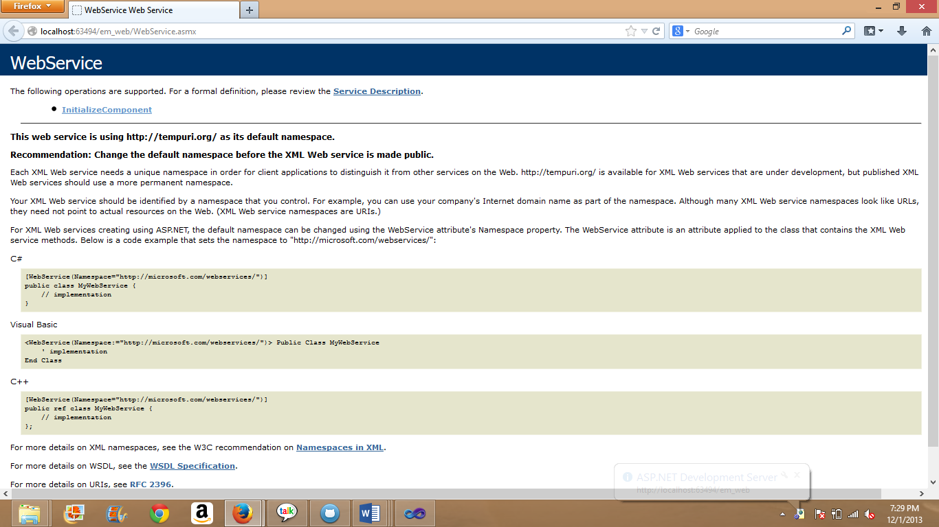

On clicking upon Initialize Component we can notice that a page displays asking him to enter to and from address along with required password and body of the message. It will now display a successful string in an xml format.

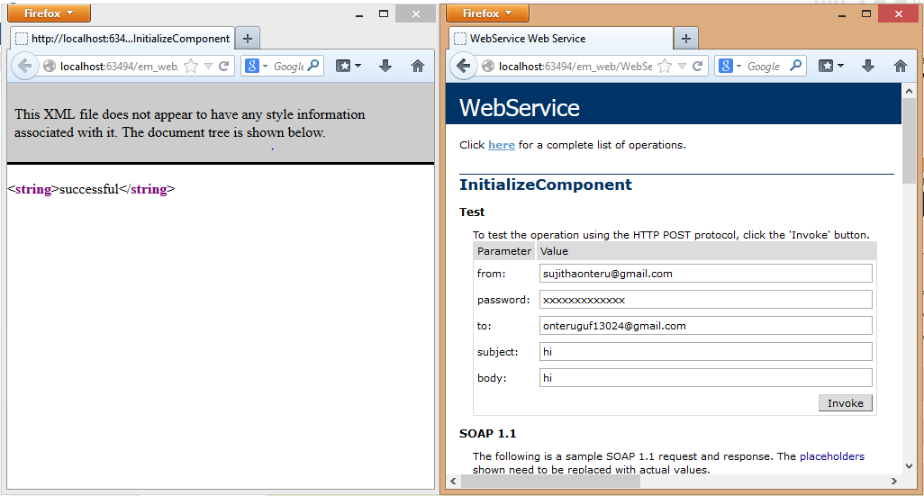

Now the service description of the local service is copied and is added as a web reference to the web application em_webapp. The needed default design layout is designed for taking the inputs from the user. And Default.aspx will have the necessary invocation code for sending the email. On debugging this on local machine it will look as follows:

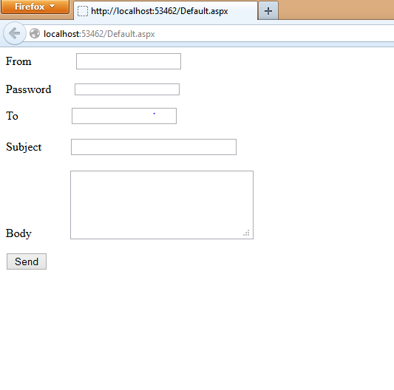

As a next step the webservice and web and web application are taken to the cloud for deployment. Once they are successfully deployed on the cloud, the remote is link is copied which is now capable of running on any machine.

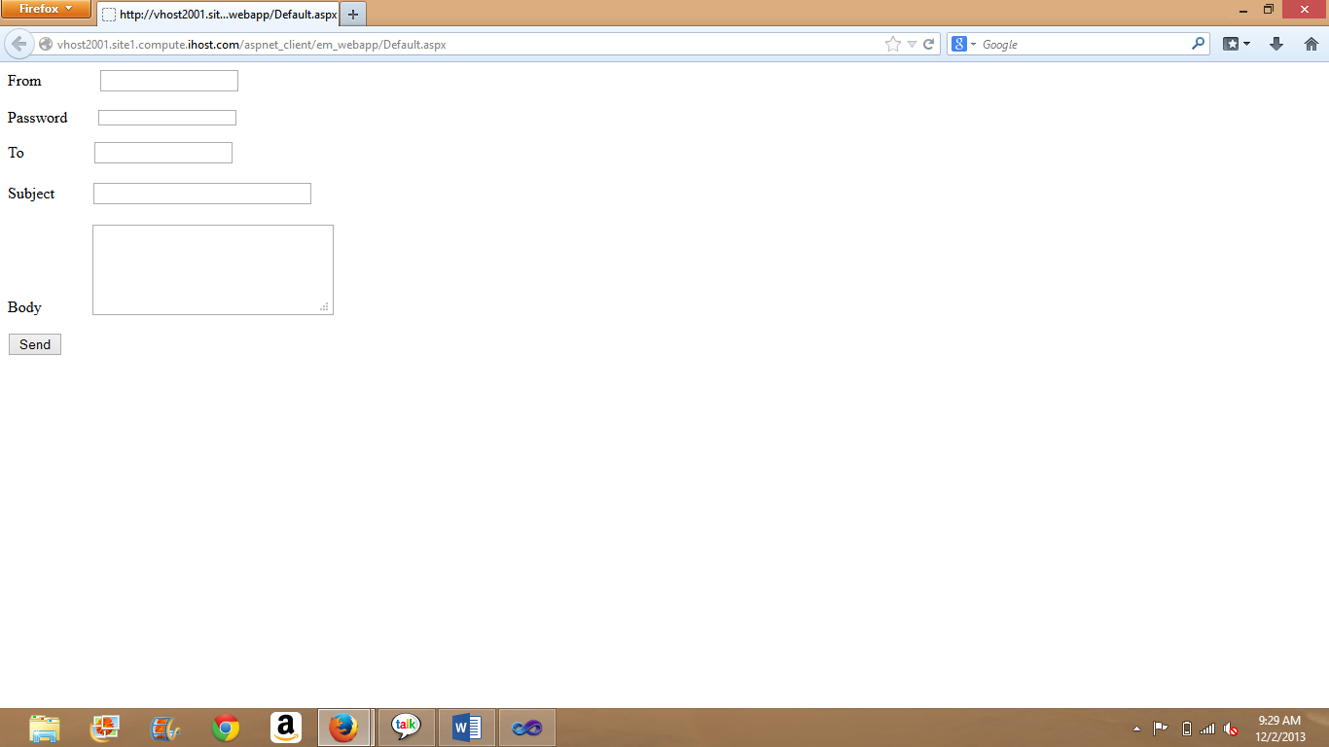

Clearly the picture shows that remotely running of the wep app is still showing allows us to get the output. It is now included into the mobile interface in jsfiddle.



**Text To Voice :**

As soon as we enter the application we can hear a voice welcoming us to travelers eye application and it asks us to select a service.

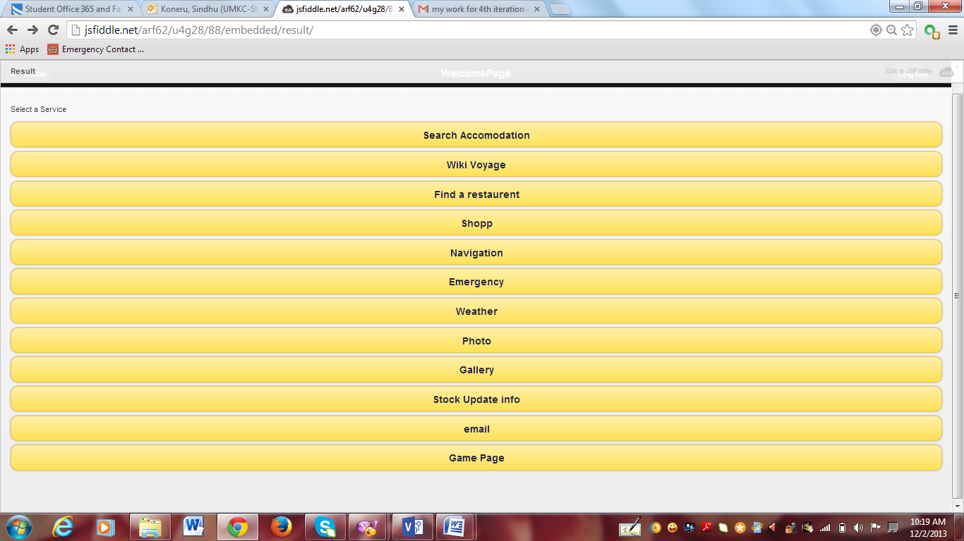

**Deployment of redesigned DB and sign up and login functionality :**

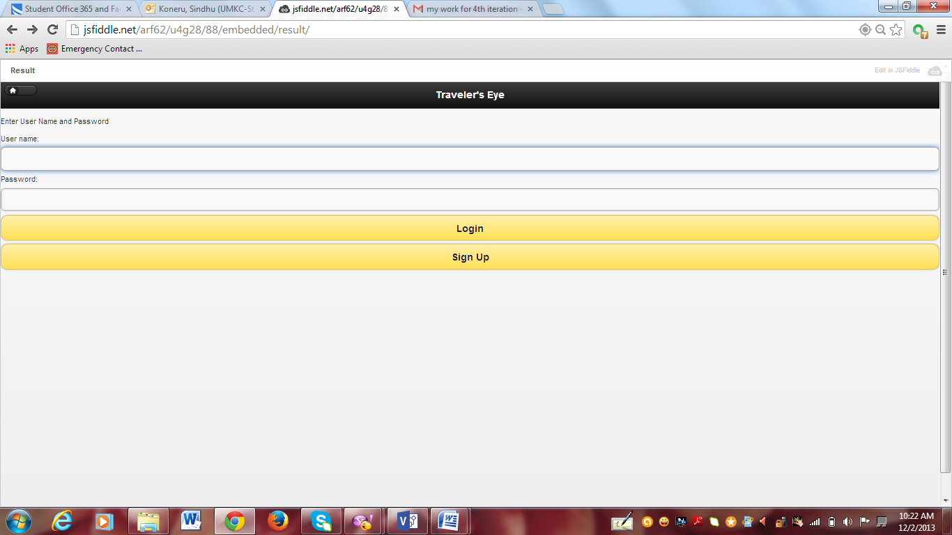

When we press sign up button over there.

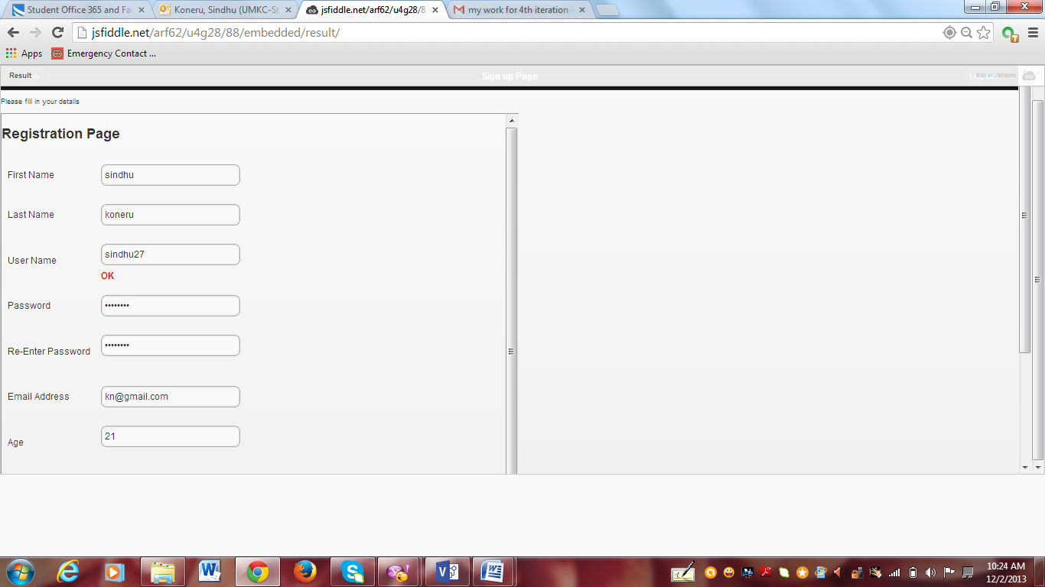

We need to fill the details and submit it.

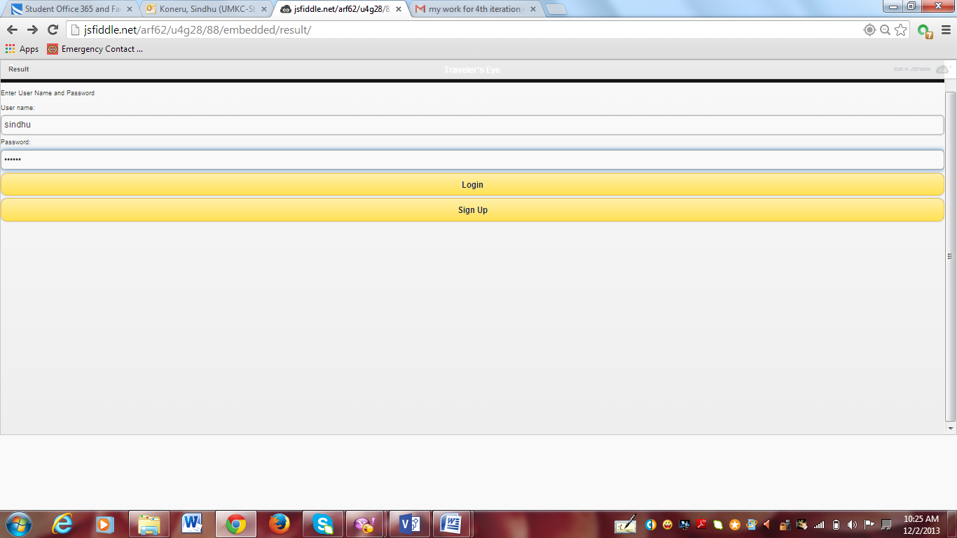

We can log in into the application by giving the user name.

**Photo & Gallery :**

Uploading photos is fun. The user of this application is not deprived of this fun. He can upload photos and see it in the gallery section.

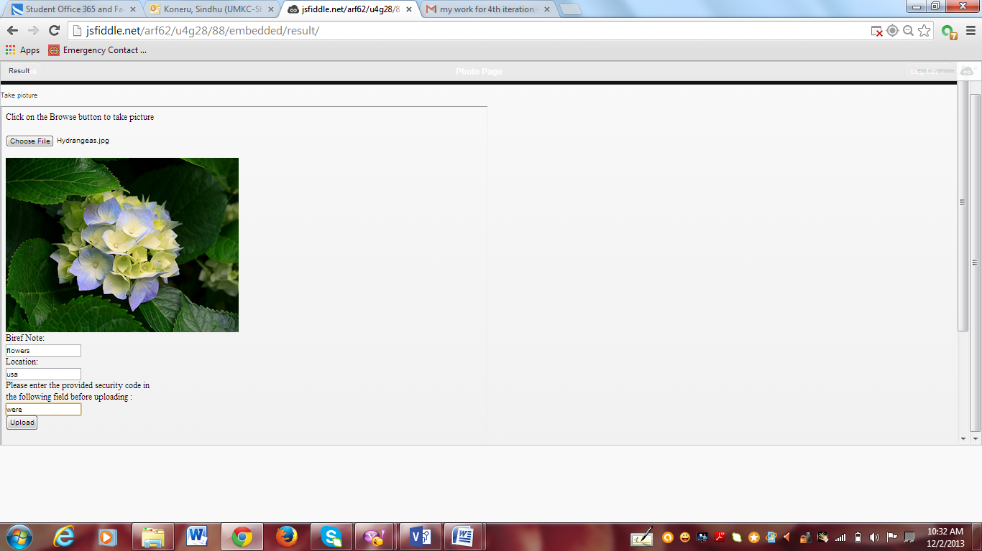

Choose the file and enter the security pin and click on the upload button.

After uploading if you go to gallery we can see all the pictures .It asks us to enter the pharse phrase(security pin) we entered while uploading. After entering that pharse phrase we can get all the pictures we uploaded.

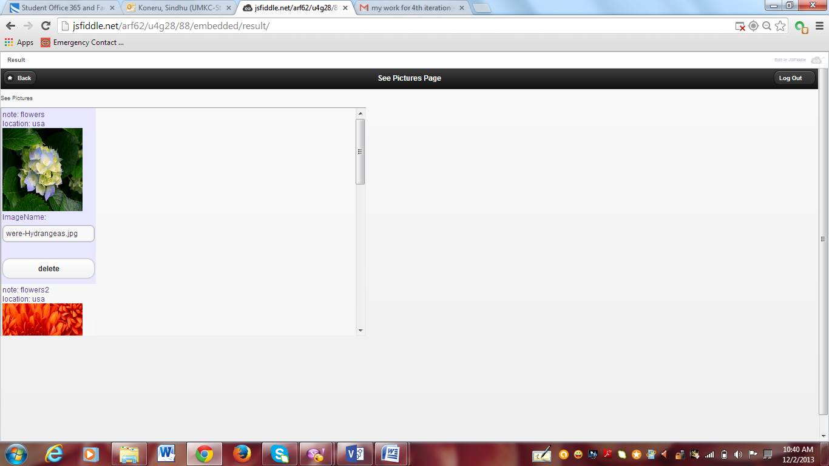

**Traveler’s Eye Web Site :**

Home Page:

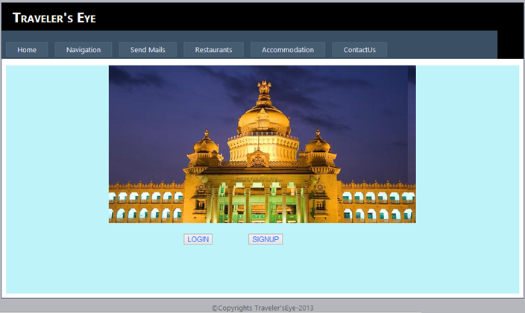

Login Page:

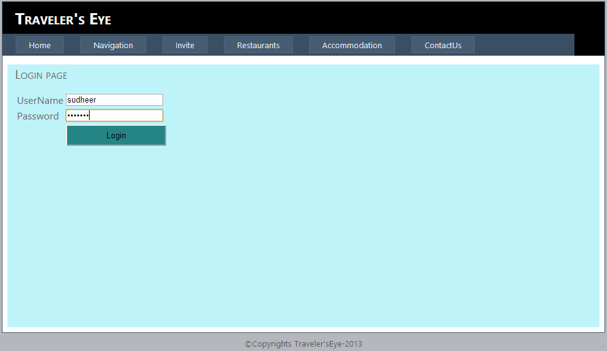

Registration Page:

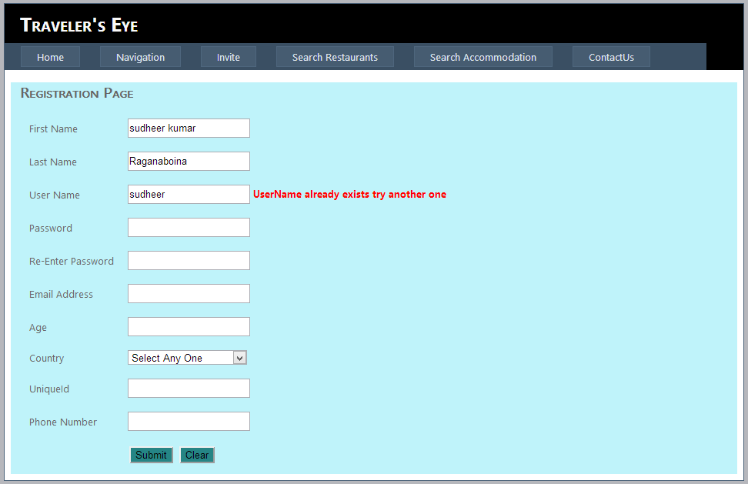

Registration Page contd:

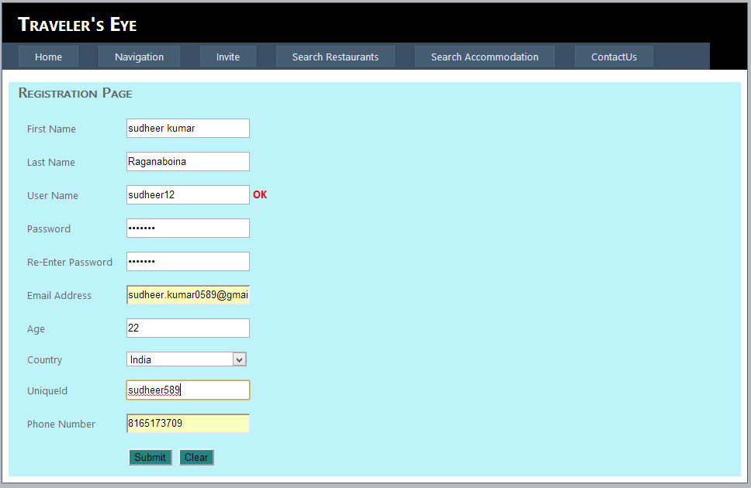

List of services that are shown to the user after login:

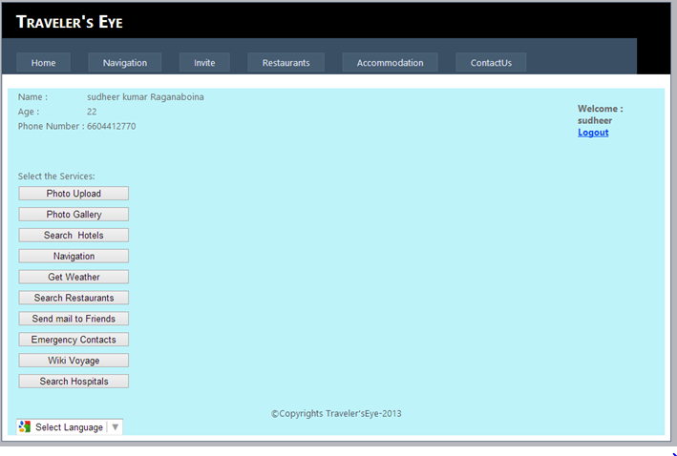

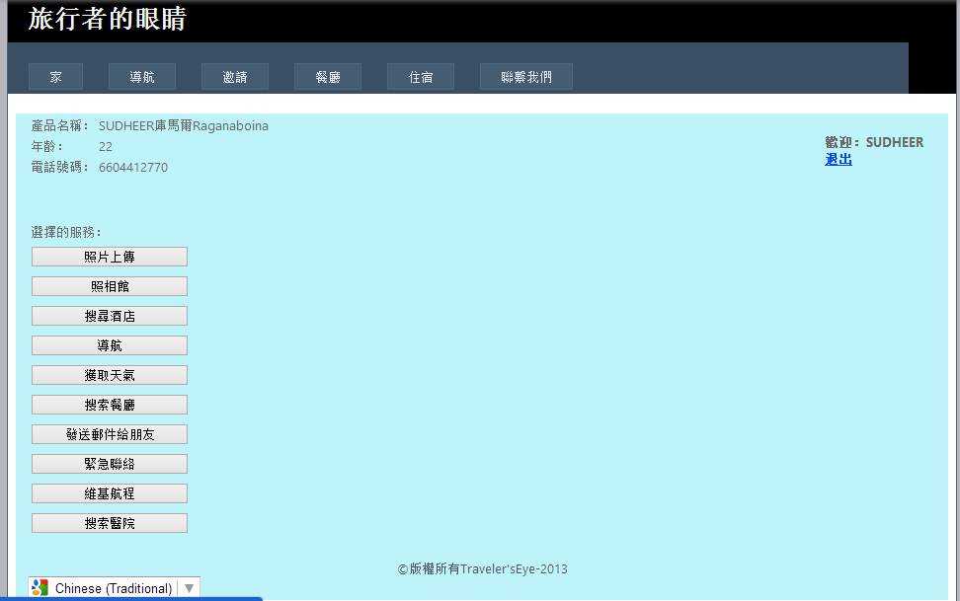

Navigation Service:

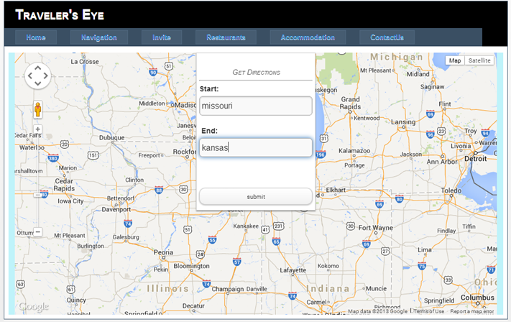

Sending Mail's :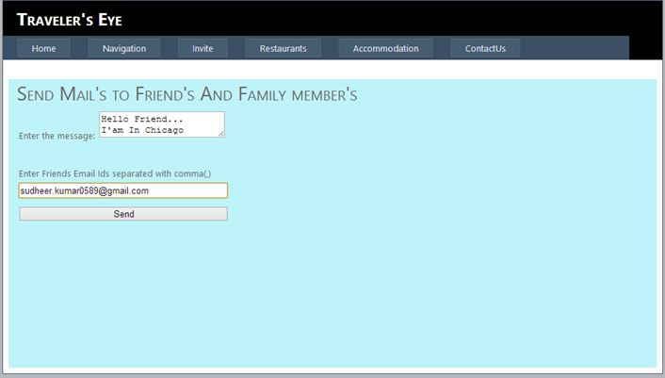

Search Hospitals:

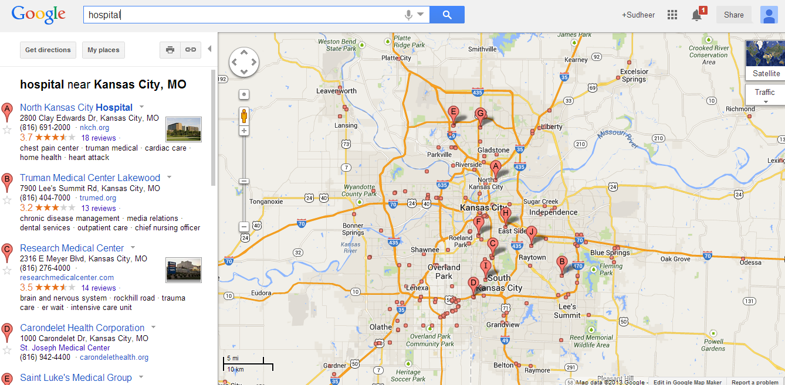

Weather Service:

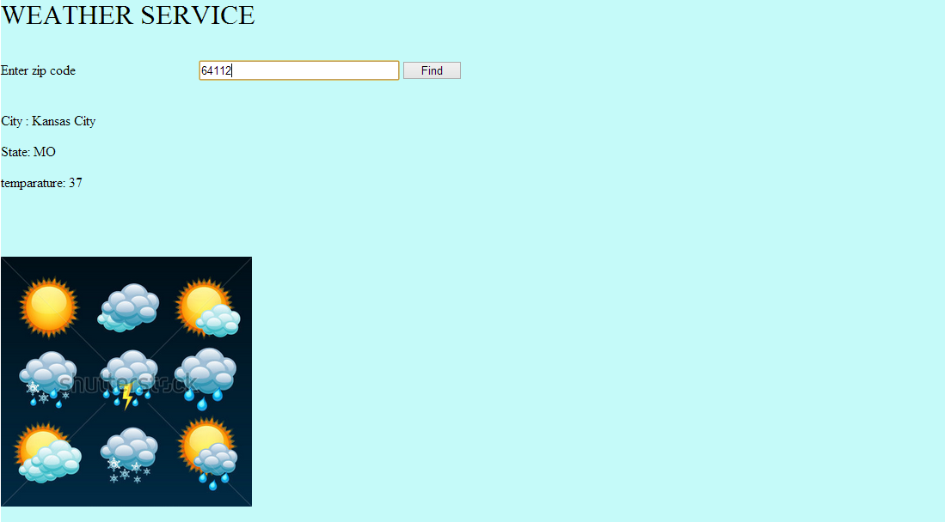

Emergency Service:

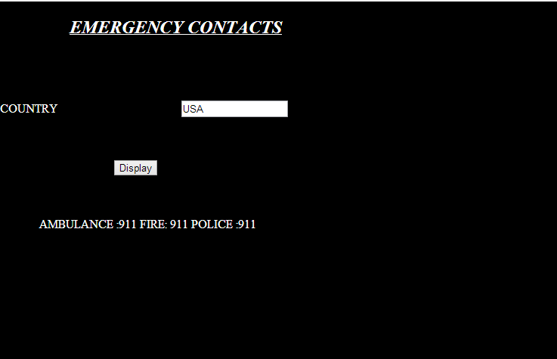

Searching Hotels:

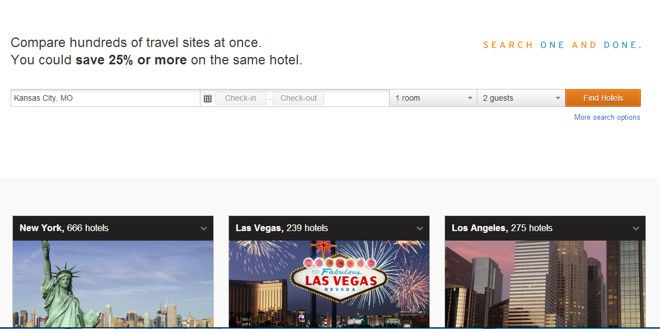

Upload Pictures:

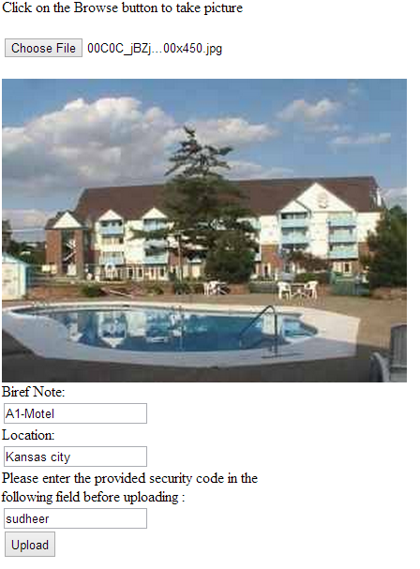

Photo Gallery:

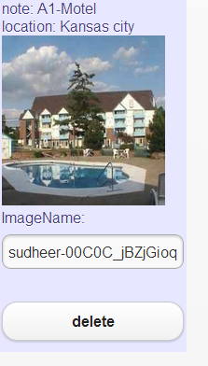

Project Management:

Sindhu Koneru: Designed a game called snake food game for entertaining the user.

Sujitha onteru: Implemented sending email to the friend at other location.

Ashok Rudraraju: Redesigning of DB and login ,sign up functionality. Photo & gallery, Text to voice.

Sudeer Kumar Raangaboina: Designed a web site for traveler’s eye.

ScrumDo Link : [https://www.scrumdo.com/projects/project/project-150/iteration/78370#](https://www.scrumdo.com/projects/project/project-150/iteration/78370)